**PCA:**

**What is PCA?**

* **Principal Component Analysis (PCA)** is a **dimensionality reduction** technique.
* It transforms the data into a new coordinate system where the axes (principal components) capture the directions of **maximum variance**.
* PCA is **unsupervised** and widely used in **data preprocessing**, **compression**, and **visualization**.

**2. Goals of PCA**

* Reduce the number of features (dimensions) while retaining most of the data’s variance.
* Find new **orthogonal axes** (principal components) in the feature space.
* **De-correlate** features and compress information efficiently.

**3. When to Use PCA**

* When your data has **many correlated variables**.
* When you want to **visualize high-dimensional data** (e.g., reducing to 2D or 3D).
* When you're preparing features for another algorithm (e.g., clustering, regression).

**PCA step-by-step**

This section will detail the mathematical steps needed to perform PCA.

1. **Standardize the data:** Scale the data to a standard normal distribution with a mean of 0 and a standard deviation of 1. This ensures that each feature contributes equally to the analysis.
2. **Calculate the covariance matrix:** This symmetric matrix summarizes the covariance between all possible pairs of features. A positive covariance indicates a positive correlation, while a negative value shows an inverse relationship.
3. **Compute eigenvalues and eigenvectors:**
   * **Eigenvectors:** These are the principal components. They represent the directions of maximum variance in the data.
   * **Eigenvalues:** These are the magnitudes of the variance explained by each corresponding eigenvector. Larger eigenvalues correspond to more significant principal components.
4. **Select principal components:** Rank the eigenvectors by their eigenvalues in descending order. Choose the top *k* eigenvectors that capture a desired percentage of the total variance.
   * **Tip for deciding *k*:** Use a scree plot, which plots the eigenvalues by rank. The "elbow" where the plot flattens out suggests an appropriate cutoff.
5. **Project data onto the new subspace:** Create a projection matrix using the selected *k* eigenvectors. Multiply this matrix by the original standardized data to transform it into the new, lower-dimensional space.

**PCA applications**

* **Image Processing:** Used for image compression and face recognition to reduce image pixel data while preserving the most important features.
* **Finance:** Analyzing stock market data to find patterns and underlying risk factors.
* **Healthcare:** Processing gene expression data to identify significant genetic patterns.
* **Recommendation Systems:** Reducing data complexity for building movie or product recommendation engines.

**PCA strengths and weaknesses**

**Advantages**

* **Reduces Overfitting:** Simplifying the data reduces model complexity.
* **Faster Algorithms:** Less data means faster training times.
* **Improves Visualization:** Makes it possible to plot high-dimensional data.
* **Noise Reduction:** Helps remove irrelevant information.

**Disadvantages**

* **Loss of Interpretability:** The principal components are new synthetic variables, making it difficult to interpret their meaning compared to the original features.
* **Information Loss:** Some information is discarded when components with low variance are removed.
* **Sensitive to Scaling:** The technique is highly dependent on the scaling of the variables. Proper standardization is crucial.
* **Assumes Linearity:** PCA is a linear technique, which means it may not be effective for data with complex, non-linear relationships.

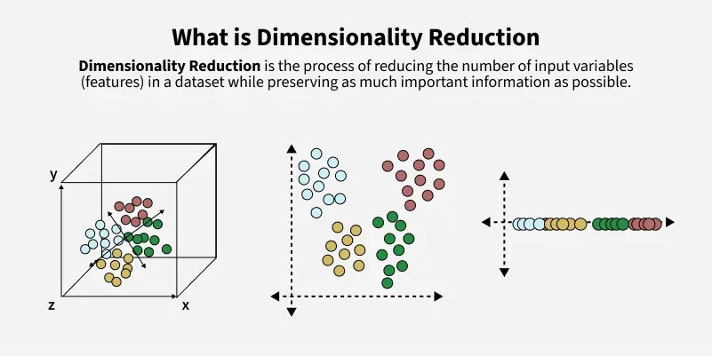

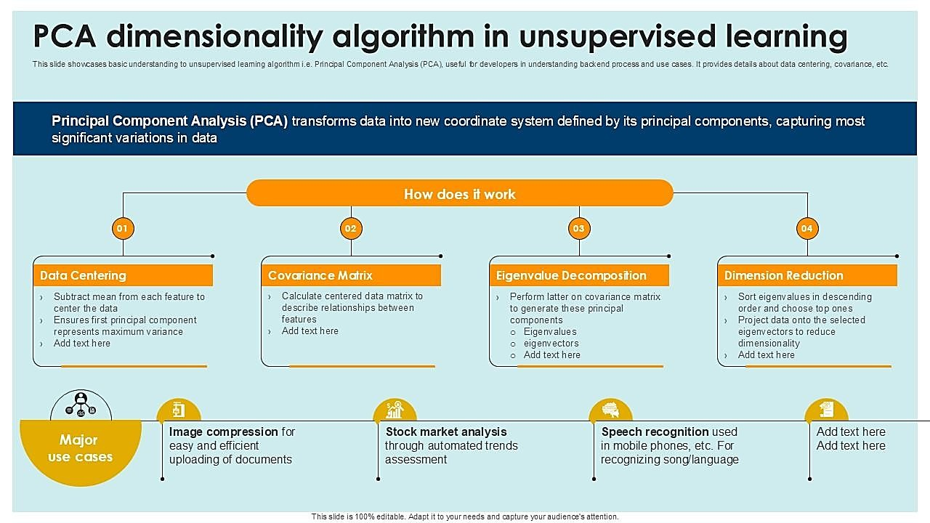

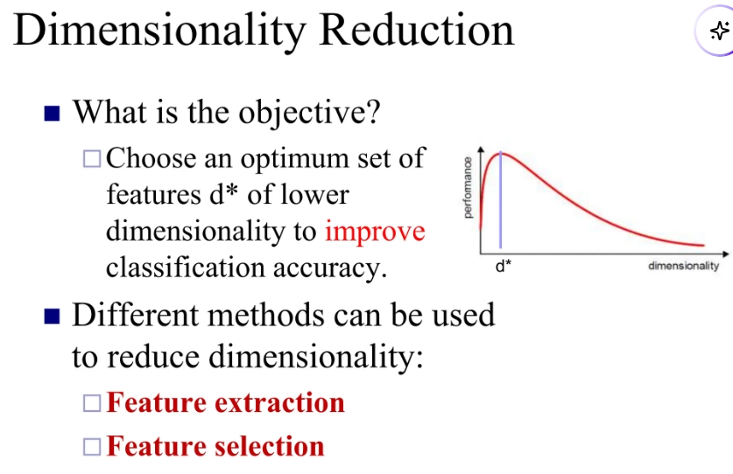

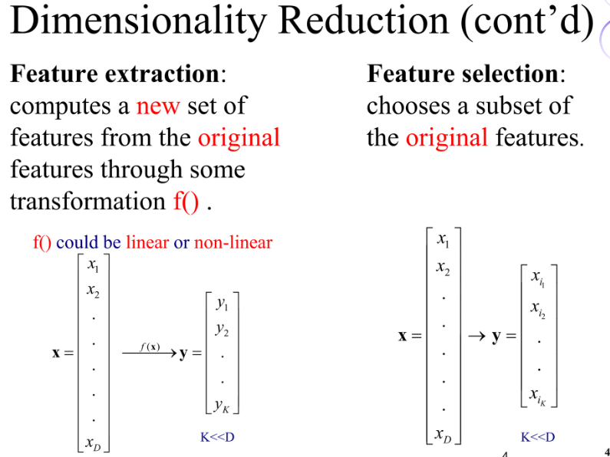

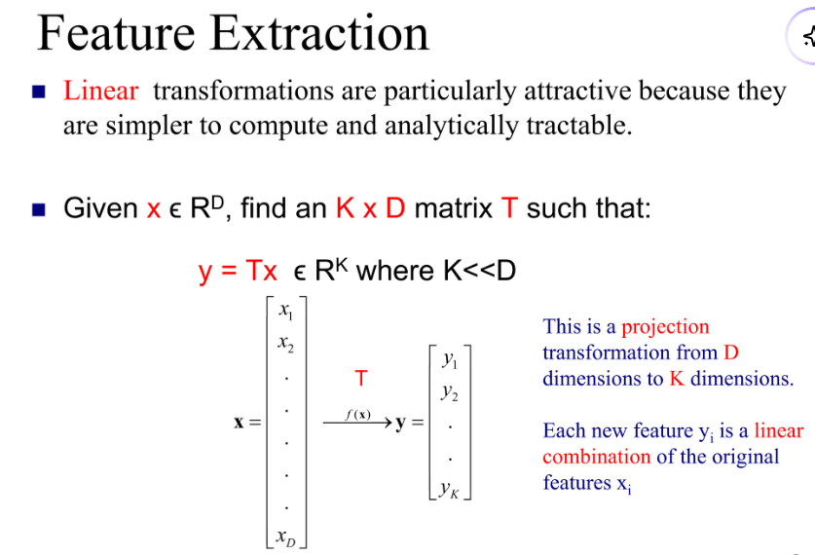

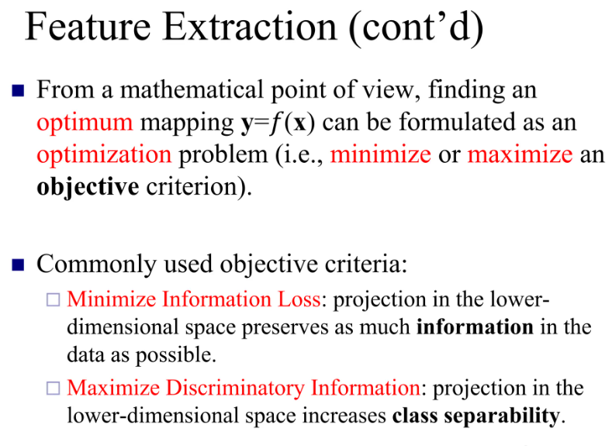

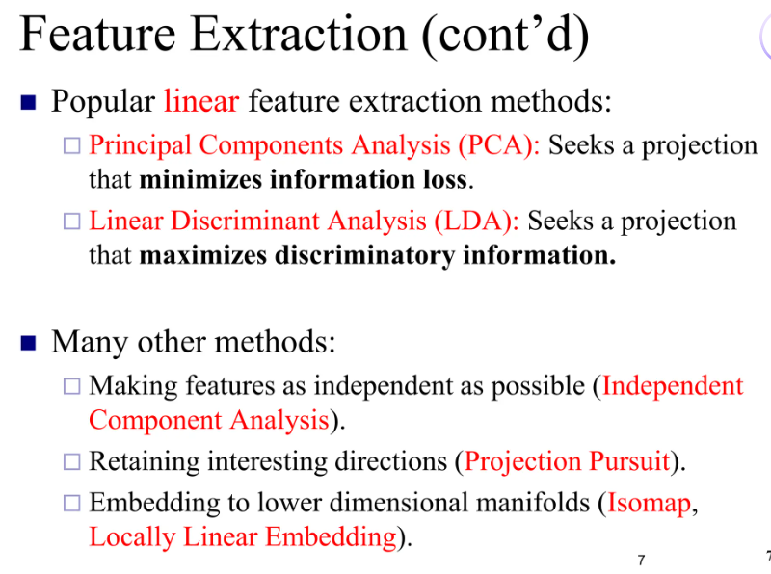

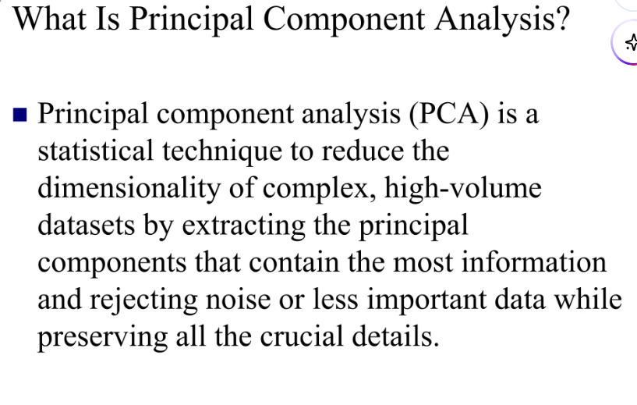

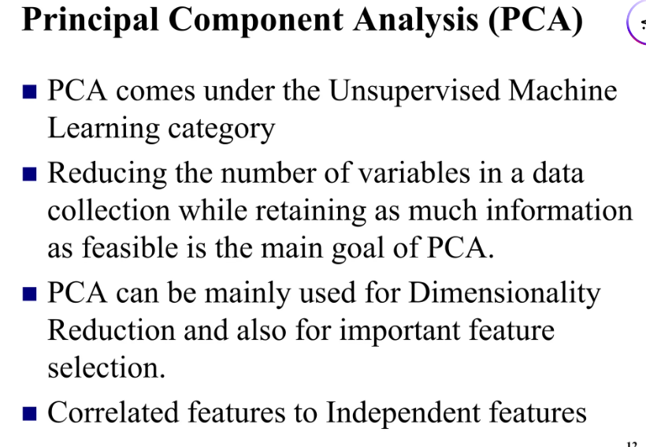

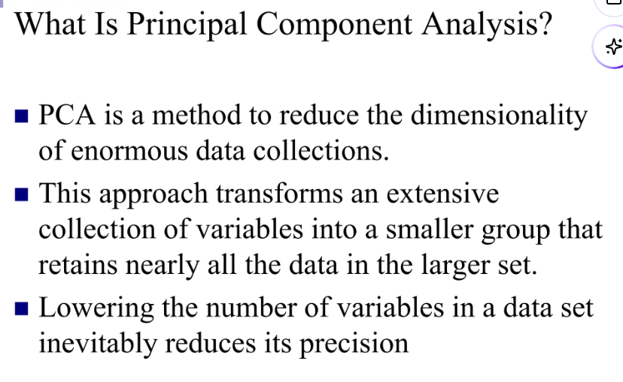

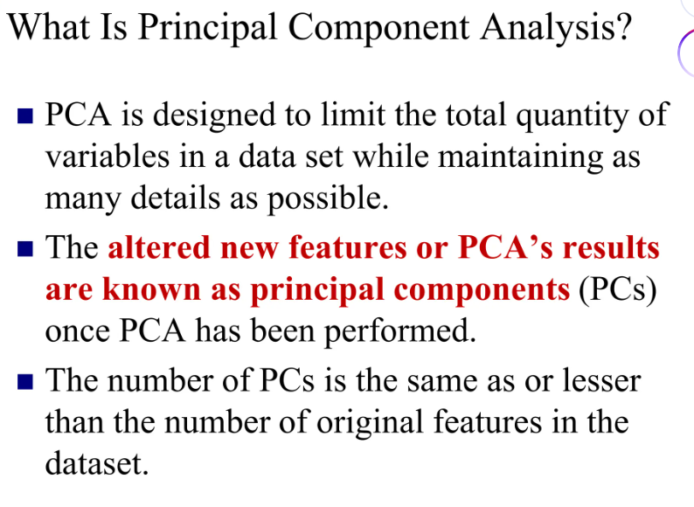

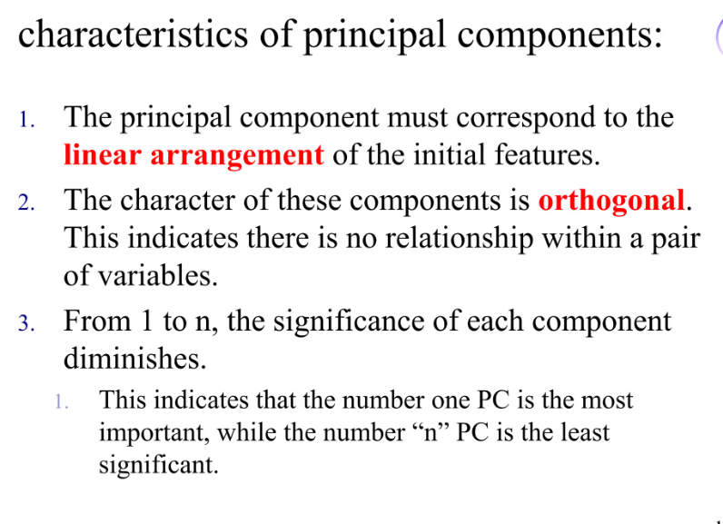

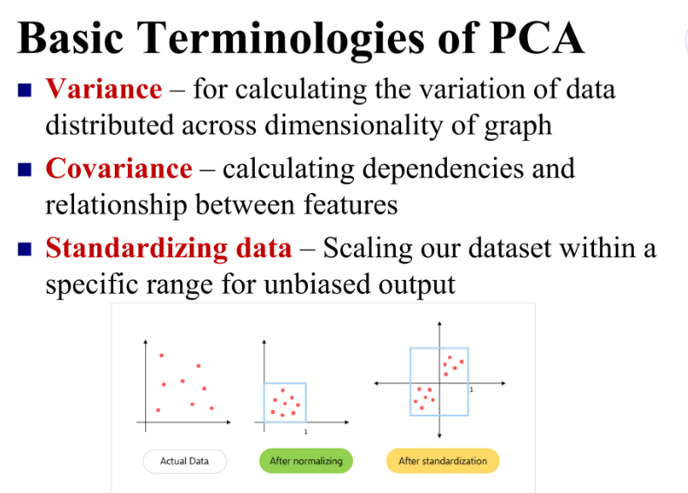

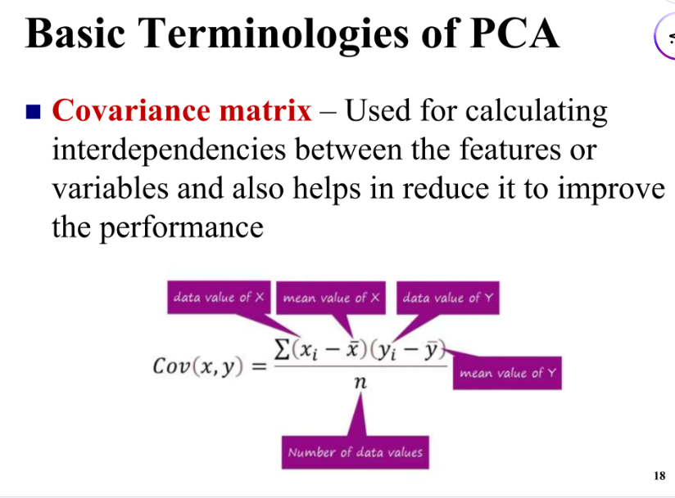

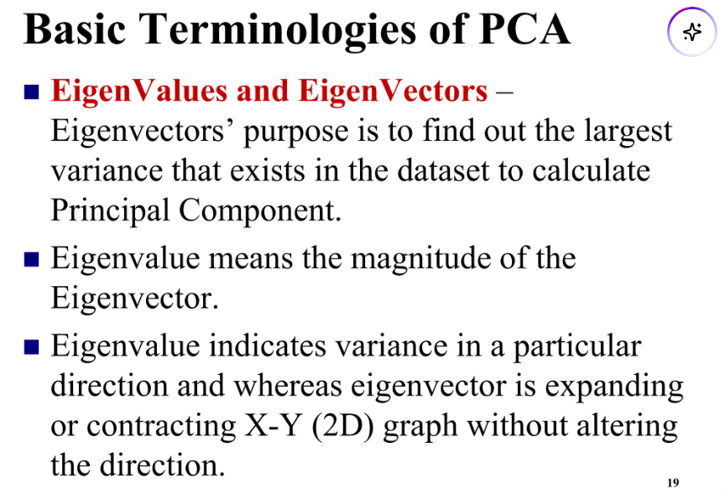

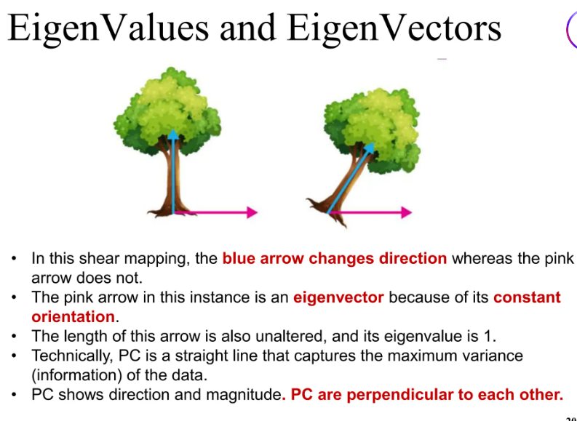

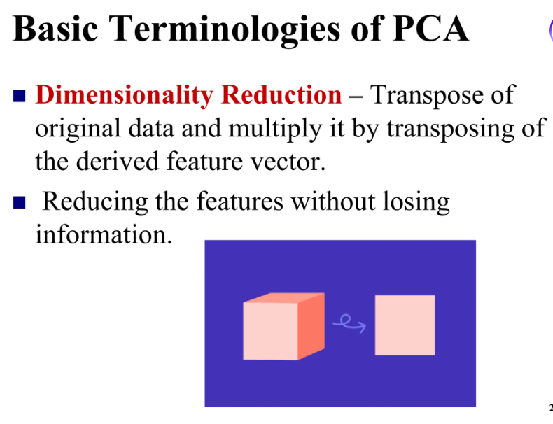

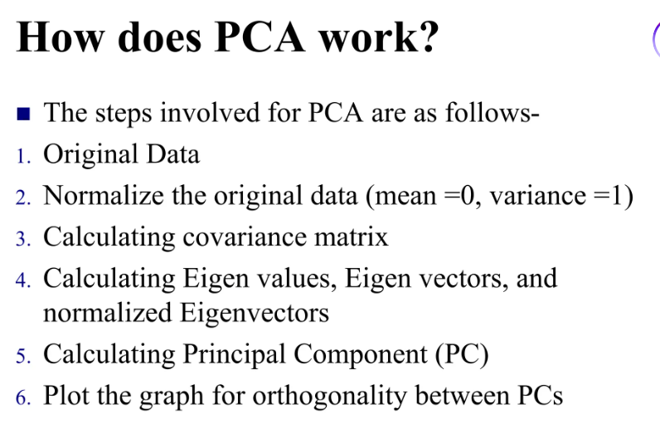

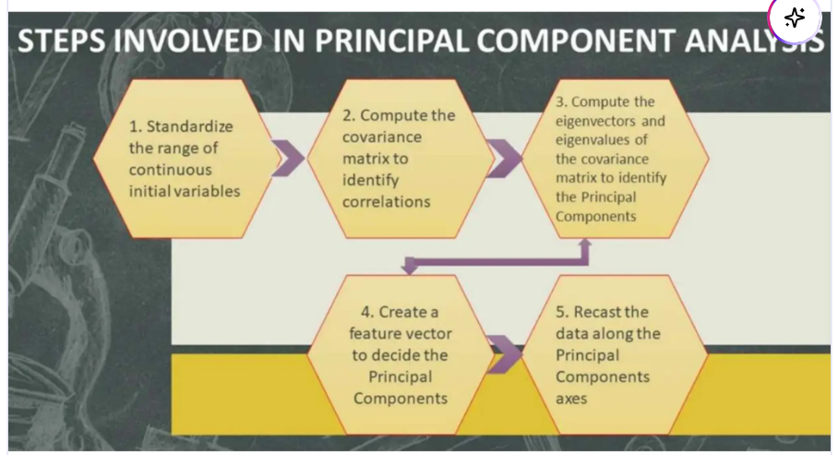

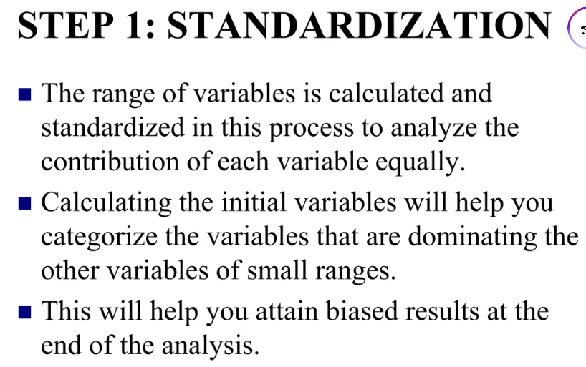

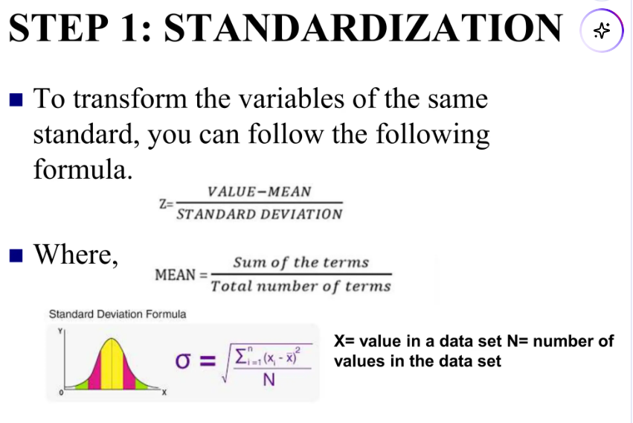

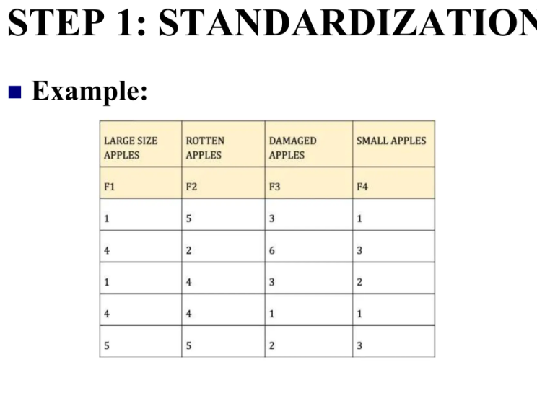

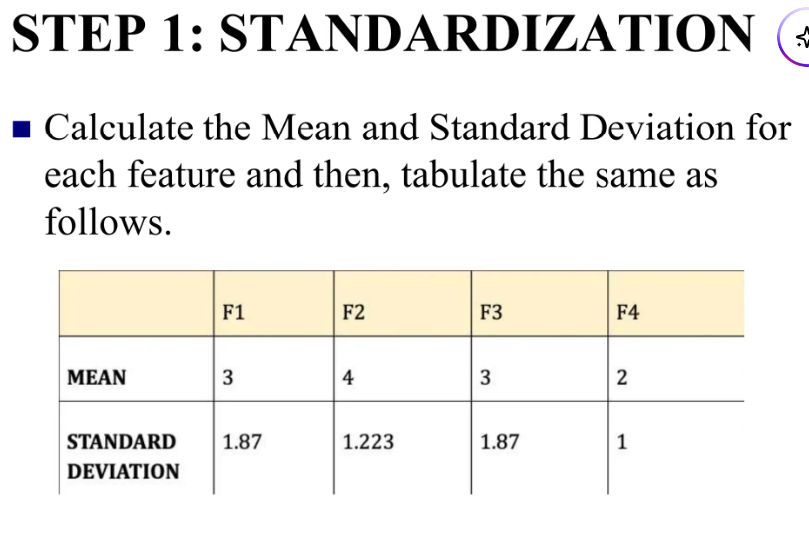

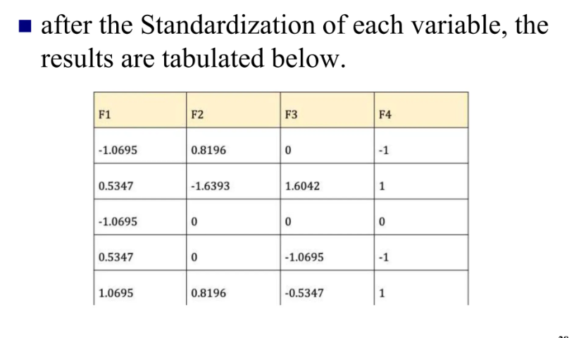

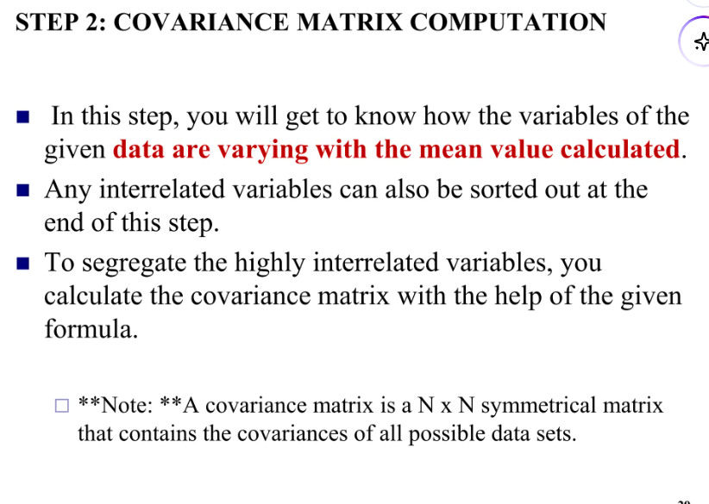

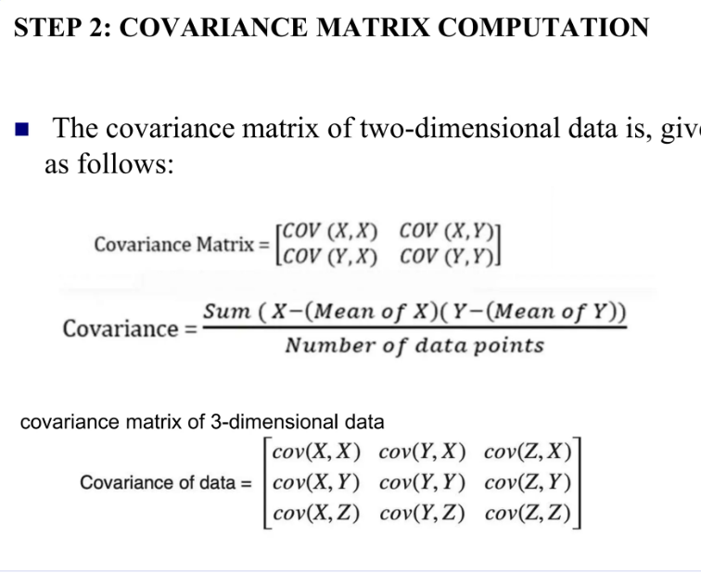

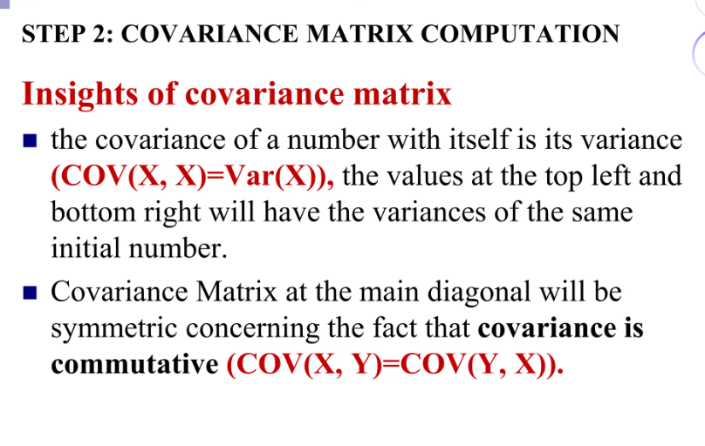

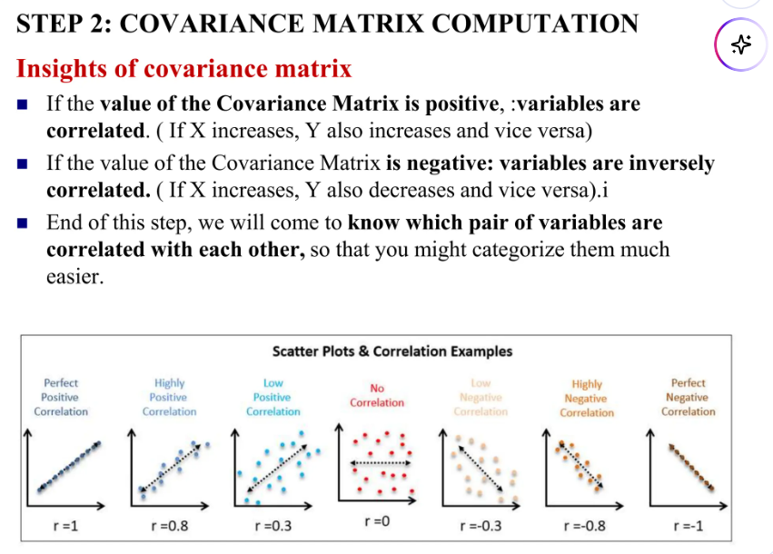

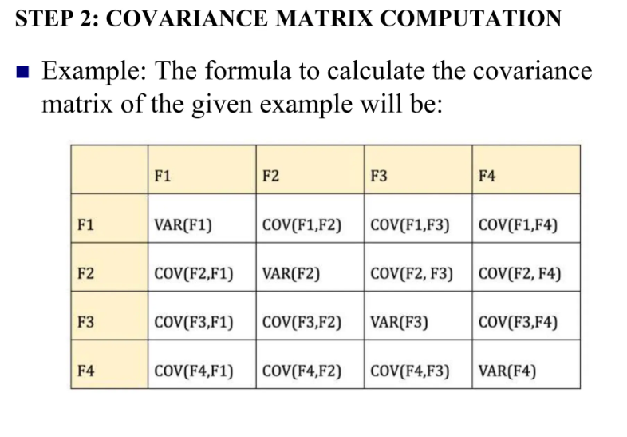

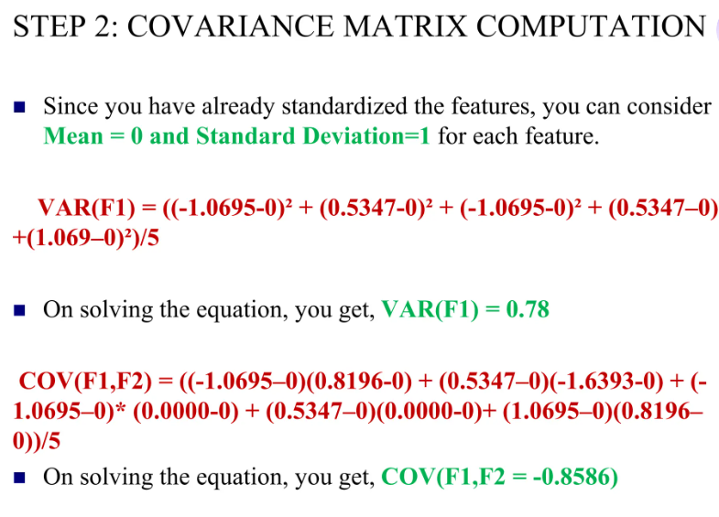

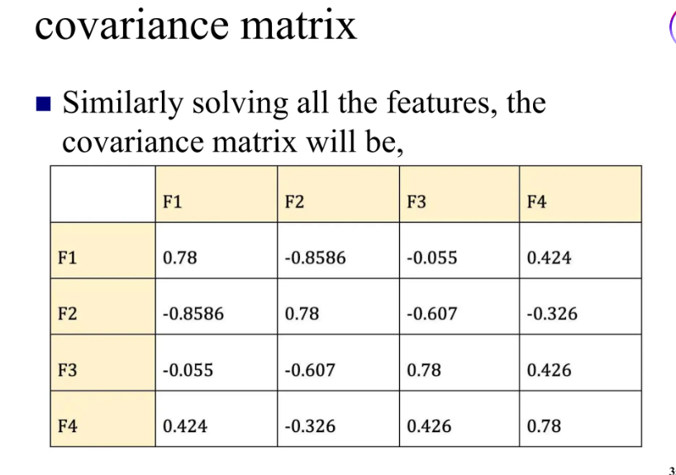

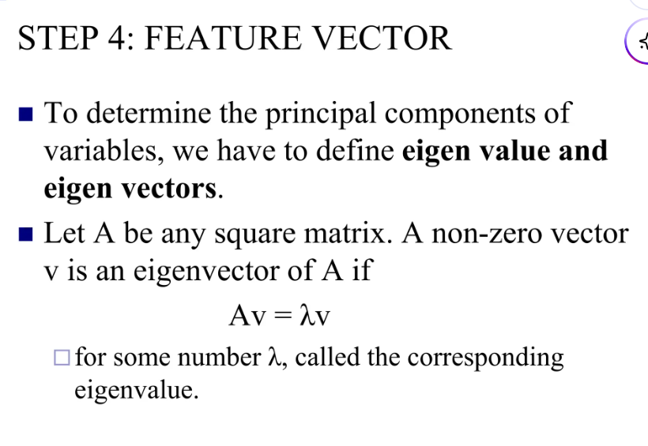

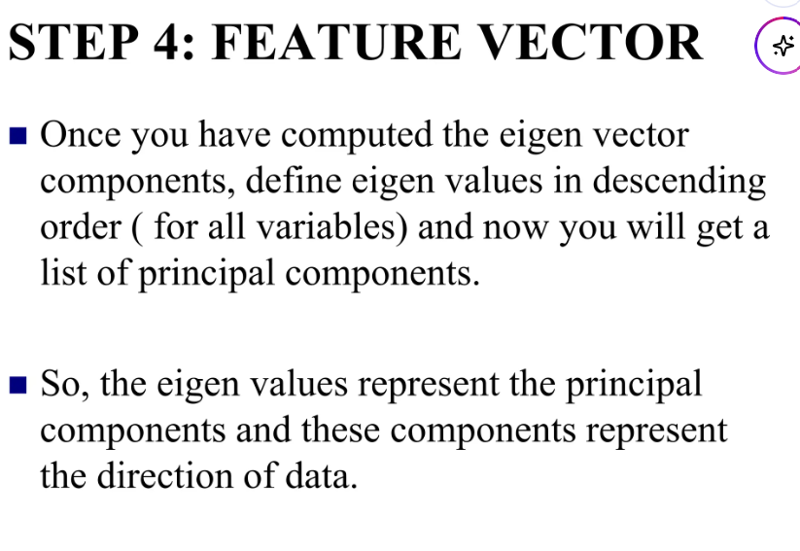

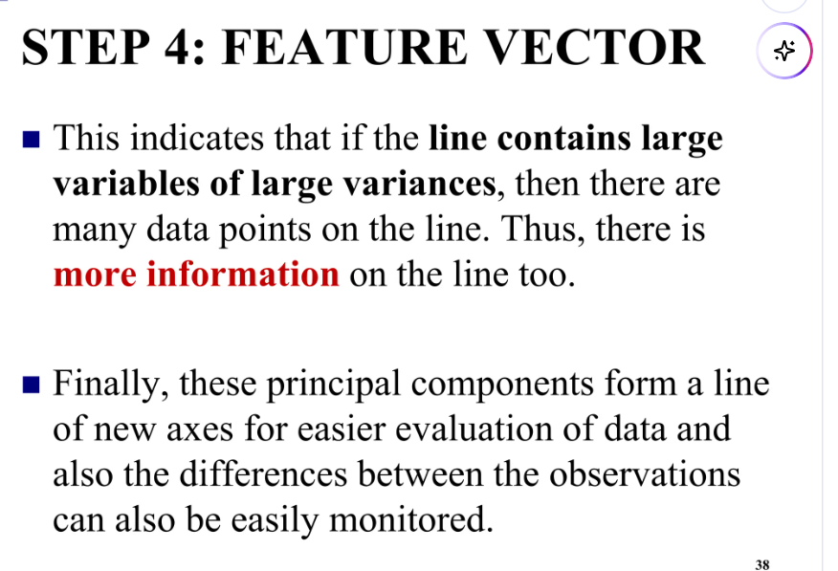

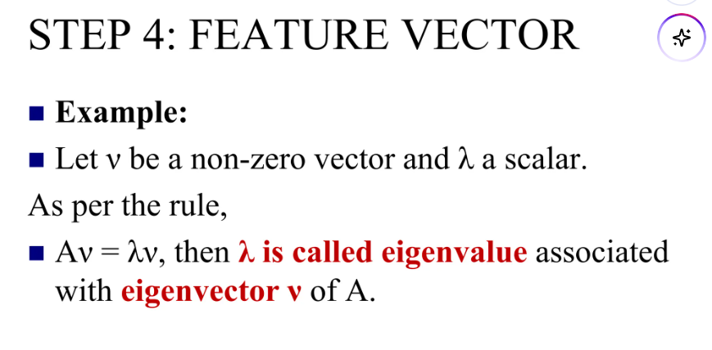



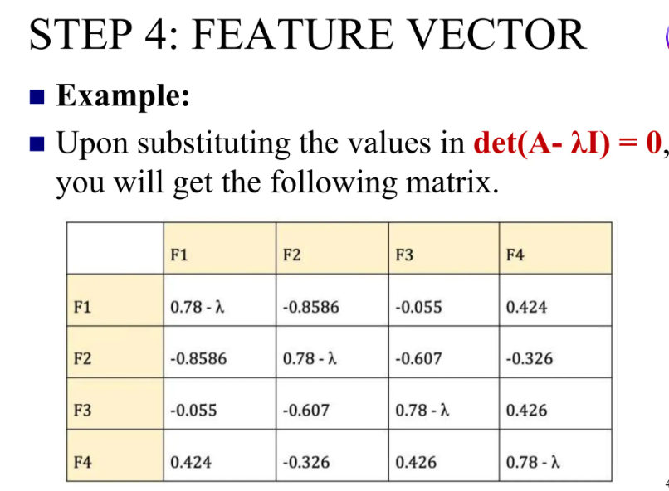

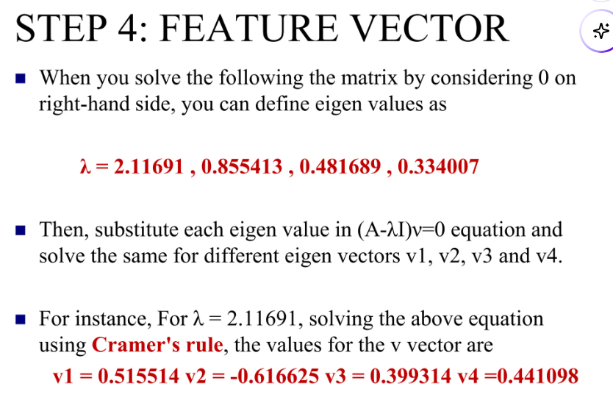

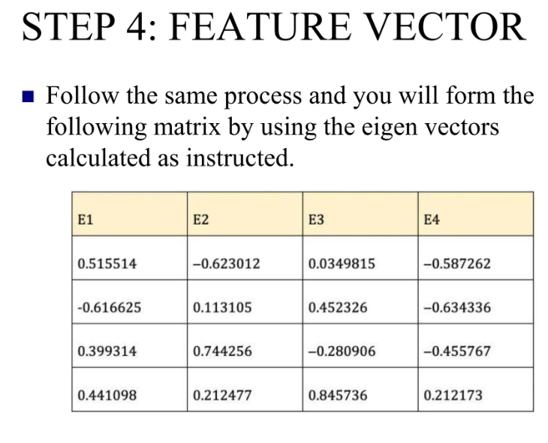

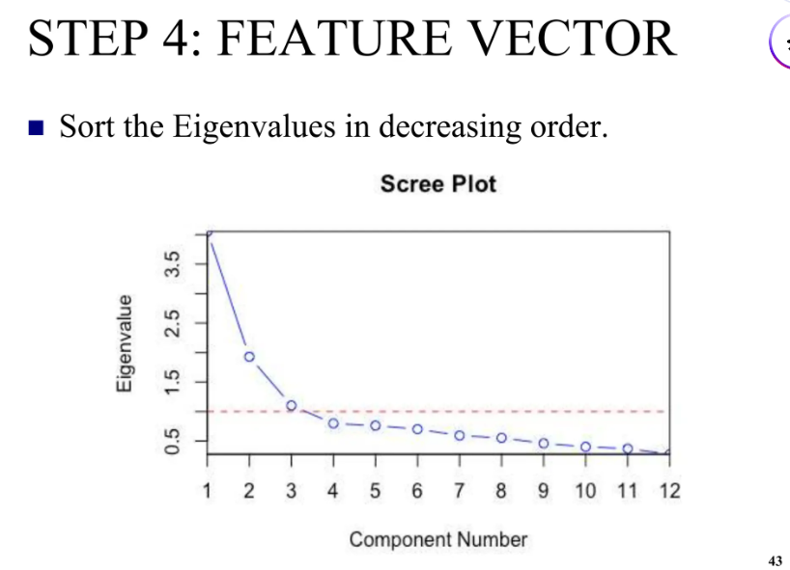

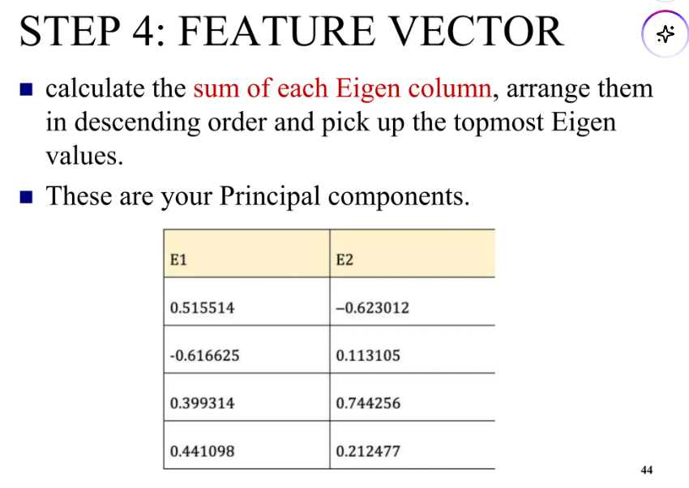

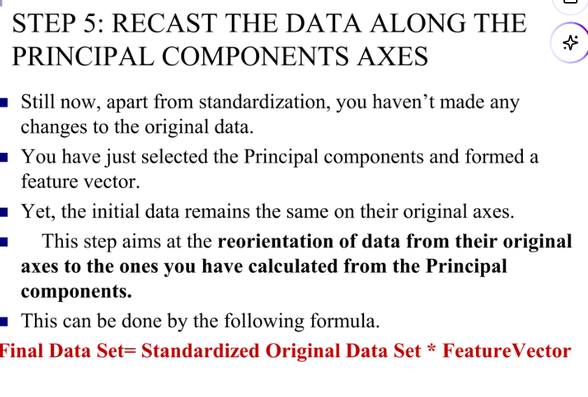

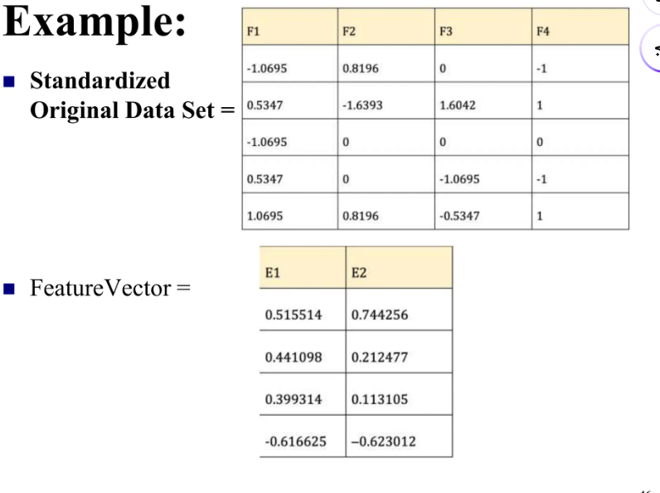

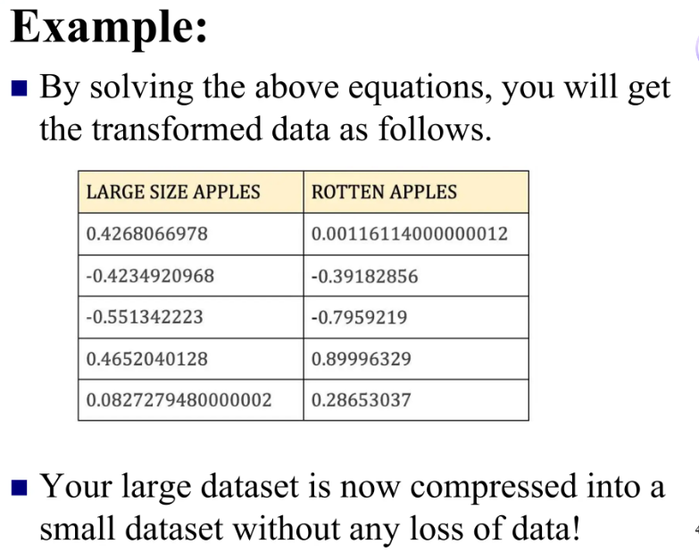

**Applications**

* **Image compression** (e.g., eigenfaces).
* **Noise filtering**.
* **Feature visualization** (2D or 3D projection).
* **Preprocessing** for ML models.
* **Summary**

| **Concept** | **Description** |
| --- | --- |
| Mean-Centering | Subtract mean from each feature |
| Covariance Matrix | Measures variance between features |
| Eigenvectors | New feature directions |
| Eigenvalues | Variance captured by each direction |
| Projection | Rotate data into new subspace |

**Example Dataset**

Imagine we have this 2D dataset of 4 points (features: height and weight):

| **Person** | **Height (cm)** | **Weight (kg)** |
| --- | --- | --- |
| A | 170 | 65 |
| B | 160 | 59 |
| C | 180 | 72 |
| D | 175 | 70 |

We want to reduce this 2D data to **1D**, while preserving as much variation as possible.

